ASR 4343
Date: 2014.04.15
Description:
Request to display individual line M3 and total TO M3.

After quick access, it’s possible to display line M3.
However total TO M3 will be not possible at the moment.

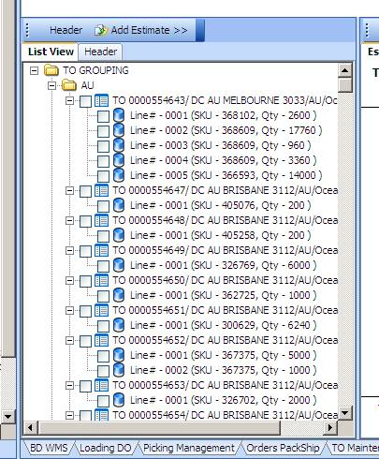
To display TO’s total M3
To display individual line’s M3

